Advance JavaScript

Tag and attributes :

<script src="pr.js" type="module"></script>

Here : script is tag and src,type are attrubutes .

Node in DOM:

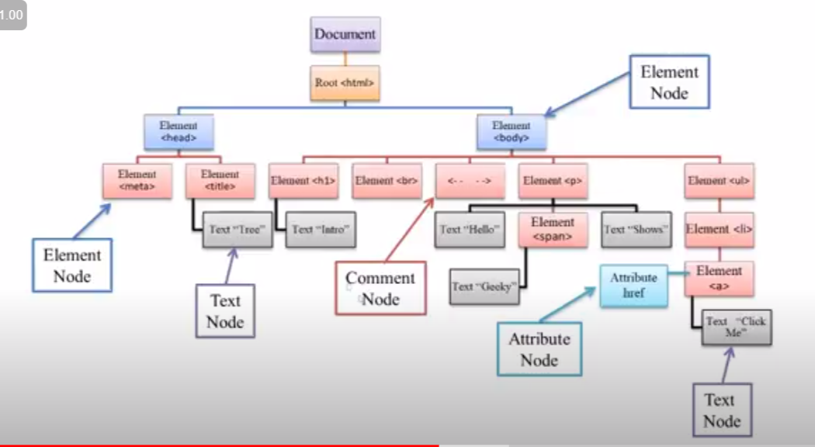

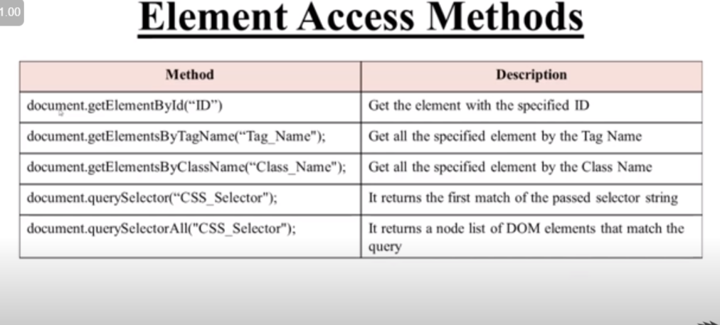

1.getElementByTagName:

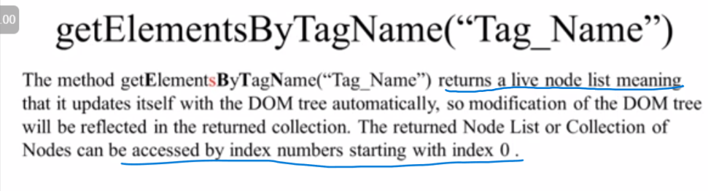

Note :i) to getting all the tage : we use “*”

Doucument.getElementByTagName(“*”)

ii) if we want to select specific tag in any header/class/id :

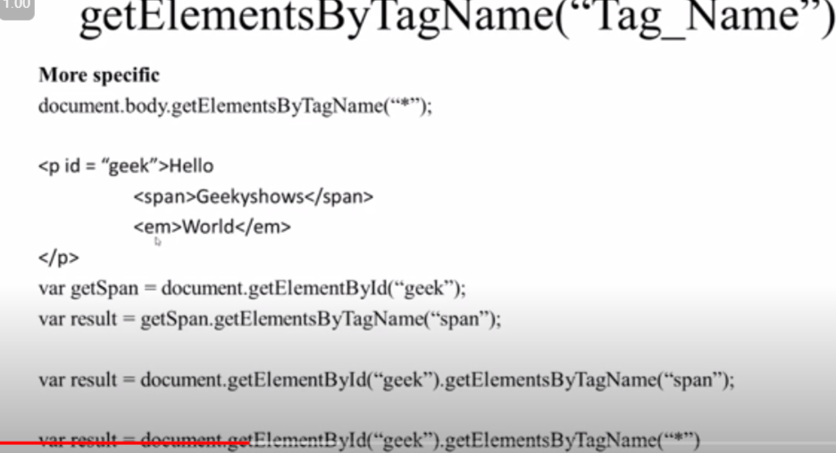

iii) to find the length of how many element are present in selected tag:

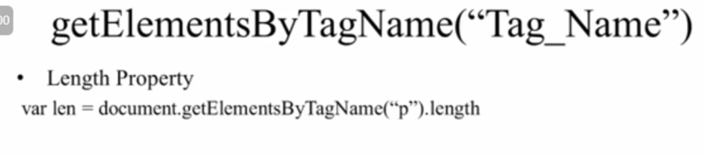

🡺 Get Element by class name :

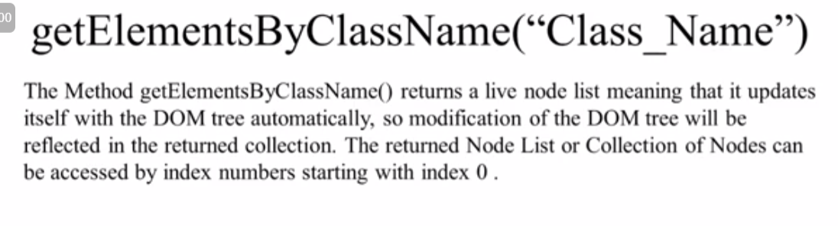

Note:

We can give multiple class in it.

Eg :

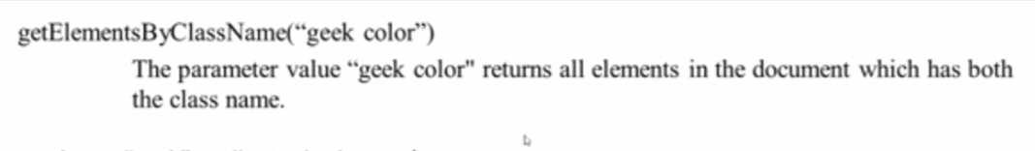

It will only going to select where class=”geek colour”; it will not going to select any class=”geek” or class=”colour”;

ii) here we also can use multiple selector eg :

document.body.getelementbyclassName(“geek”);

class name length property :

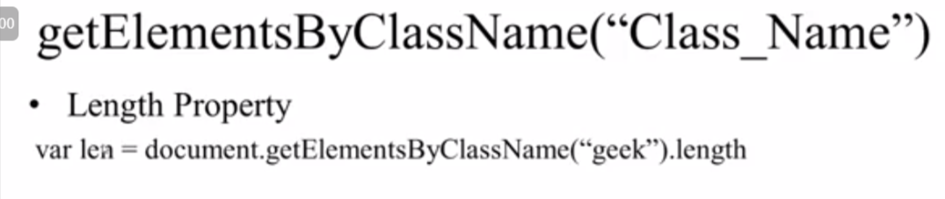

Qurey selector :

🡺 query slector with the multiple element 🡪

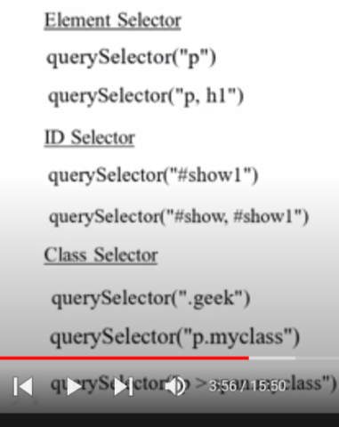

It will going to select the first element found .

Query slector all :

It return a node static list .

Note : we can also pass multiple element in it .

We can also get the length of query slector all .

Web page properites :

1. To know the properties of web page we need to write :

Console.dir(document)🡪

styles.masthead_custom_styles, style.searchbox, style.kevlar_global_styles, meta, link, link, div, style, iron-iconset-svg, svg, defs, g#3d-rotation,

bgColor: ""

body: body.vsc-initialized

characterSet: "UTF-8"

charset: "UTF-8"

childElementCount: 1

childNodes: *NodeList*(2) [<!DOCTYPE html>, html]

children: *HTMLCollection* [html]

compatMode: "CSS1Compat"

contentType: "text/html"

currentScript: null

defaultView: *Window* {0: *Window*, 1: *Window*, 2: global, window: *Window*, self: *Window*, document: document, name: '', location: *Location*, …}

designMode: "off"

dir: ""

doctype: <!DOCTYPE html>

documentElement: html

documentURI: "https://www.youtube.com/watch?v=thxWOb3VNbA&list=PLbGui_ZYuhihZ-pDxNZuQ7xOQ8IS2z3XI&index=19"

domain: "www.youtube.com"

embeds: HTMLCollection []

featurePolicy: FeaturePolicy {}

fgColor: ""

firstChild: <!DOCTYPE html>

firstElementChild: html

fonts: FontFaceSet {onloading: null, onloadingdone: null, onloadingerror: null, ready: *Promise*, status: 'loaded', …}

forms: HTMLCollection [form#search-form.style-scope.ytd-searchbox, search-form: form#search-form.style-scope.ytd-searchbox]

fragmentDirective: FragmentDirective {}

fullscreen: false

fullscreenElement: null

ontimeupdate: null

ontoggle: null

ontransitioncancel: null

ontransitionend: null

ontransitionrun: null

ontransitionstart: null

onvisibilitychange: null

onvolumechange: null

onwaiting: null

onwebkitanimationend: null

onwebkitanimationiteration: null

onwebkitanimationstart: null

onwebkitfullscreenchange: null

onwebkitfullscreenerror: null

onwebkittransitionend: null

onwheel: null

ownerDocument: null

parentElement: null

parentNode: null

pictureInPictureElement: null

pictureInPictureEnabled: true

plugins: *HTMLCollection* []

pointerLockElement: null

previousSibling: null

readyState: "complete"

so with the help of document we can get or acess :

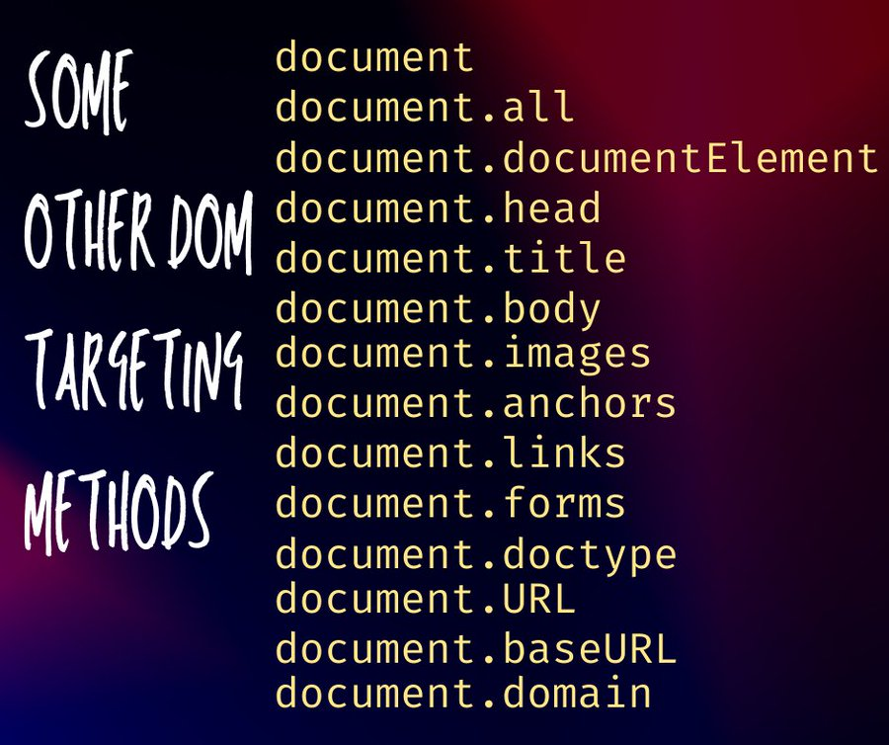

Note : we can console this as well .

Node property :

1. Element.nodeValue :property it give the value inside the selected content .

2)element.nodeName : it give the name of the slected element .

Note : we can use nodeName and Nodvalue property with the every slected element to know the name and value . and we can change them as well .

🡺 Attributes :

*const* script=document.querySelector('script');

console.log(script.attributes)

it will going to give all the attributes present in the script .

ii)To acess the attributes spefically :we use .attributes[index]

*const* script=document.querySelector('script');

console.log(script.attributes[0].nodeName)

console.log(script.attributes[0].nodeValue)

iii) length property of attributes : .attributes.length

🡺using Name and Value instead of nodeName and NodeValue

iv)with attributes we can use : .attributes[index].name or .attributes[index].value

🡺 parent node vs parent element :

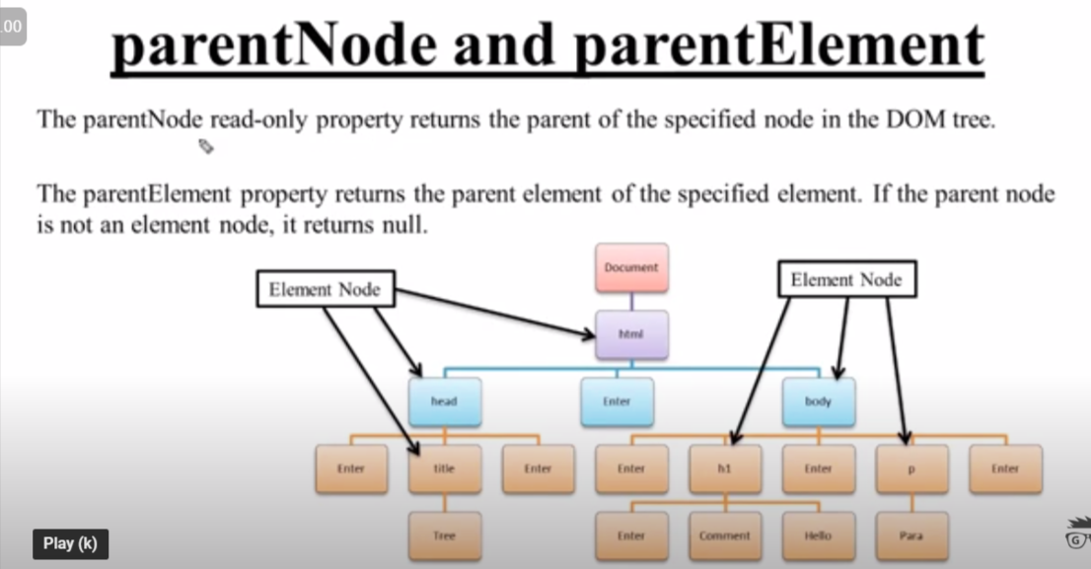

🡺 Diffrence between childnodes and chlideren :

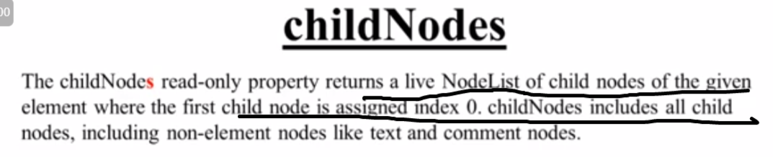

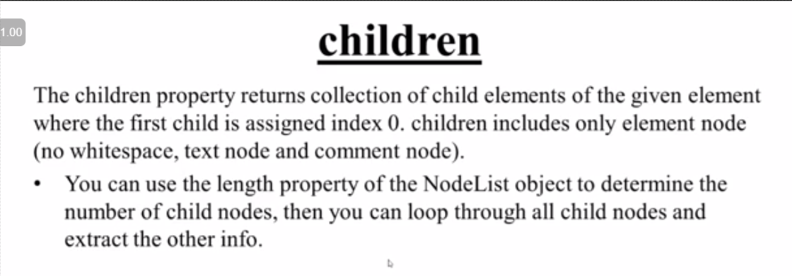

Creating Node :

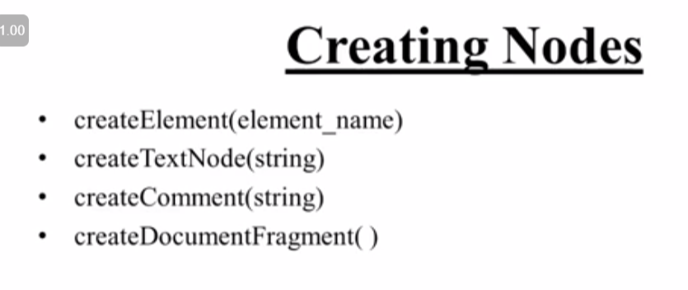

🡺Creating a text node :

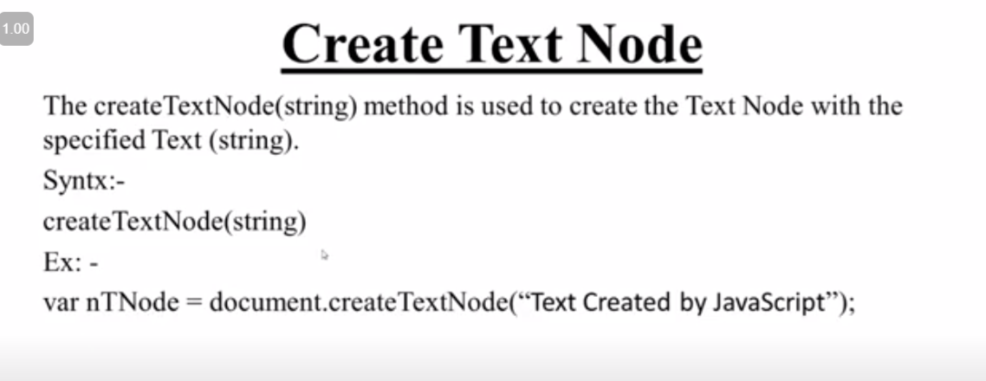

🡺creating comment node :

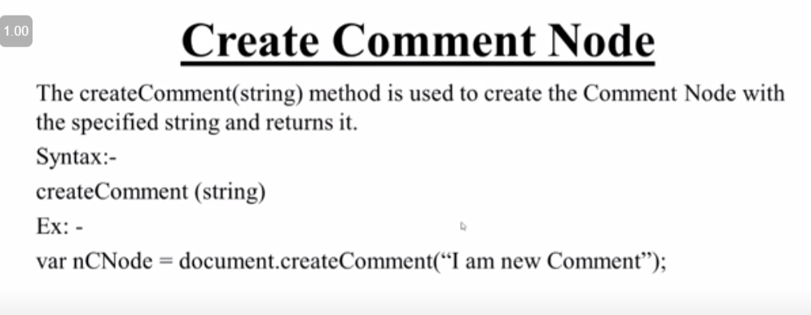

🡺 document Fragment :

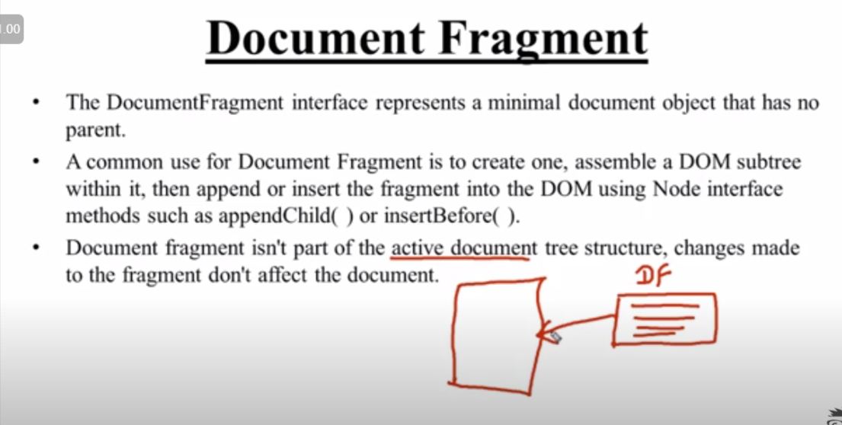

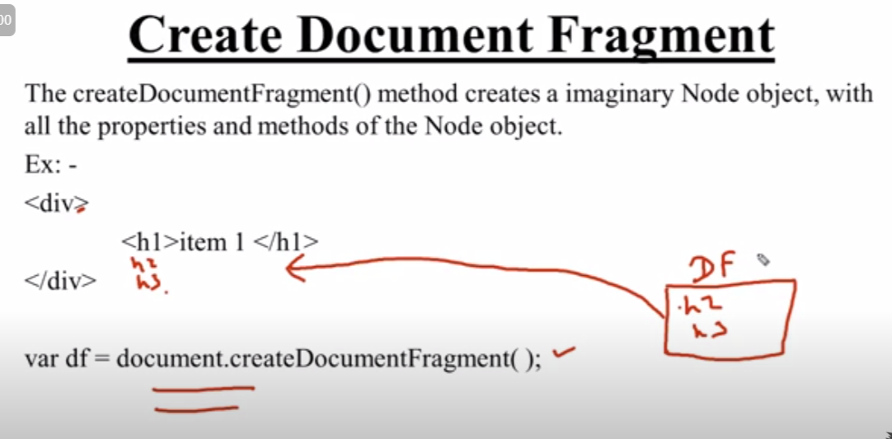

Example of fragment :

<!DOCTYPE html>

<html lang="en">

<head>

    <meta charset="UTF-8">

    <meta http-equiv="X-UA-Compatible" content="IE=edge">

    <meta name="viewport" content="width=device-width, initial-scale=1.0">

    <title>Document Fragment</title>

</head>

<body>

    <div id="myid">

        <h1>We are Learning Javascript</h1>

        <h1>I am h1</h1>

    </div>

    <script>

*let* df=document.createDocumentFragment();

*let* hnode=document.createElement('h3');

*let* pnode=document.createElement('p');

        hnode.textContent="H3 from js";

        pnode.textContent="p from js";

        df.appendChild(hnode);

        df.appendChild(pnode);

*let* target=document.getElementById('myid');

        target.appendChild(df);

    </script>

</body>

</html>

🡺1.AppendChild():

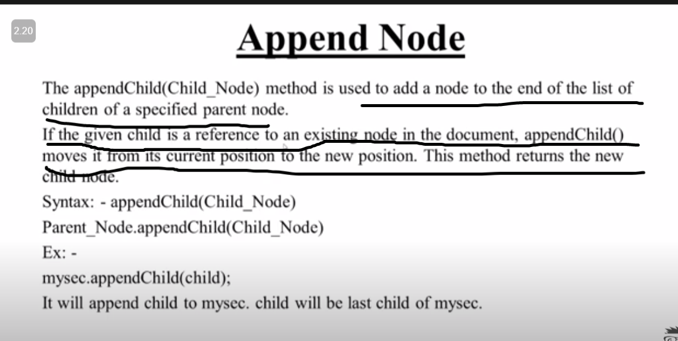

Note : we can append : node Element , text node , comment node with the help of append .

🡺 Diffrence between append and appendChild :

.append()

This method is used to add an element in form of a *Node* object or a DOMString (basically means text).

.appendChild()

Similar to the .append method, this method is used to elements in the DOM, but in this case, only accepts a *Node* object.

--Differences--

1).append accepts *Node* objects and DOMStrings while .appendChild accepts only *Node* objects

2).append does not have a return value while .appendChild returns the appended *Node* object

3).append allows you to add multiple items while appendChild allows only a single item

Difference between text content and inner text :

.textcontent():it will give all the text whether it is hidden or it is vissible on the screen

.innertext():innertext will give only visble text .

// time to excute innertext will be more than the text content .

// so , we prefer to use text content when ever we need of text .

Note : if we use inner text or textContent both of them will going to give the whole text node of child :

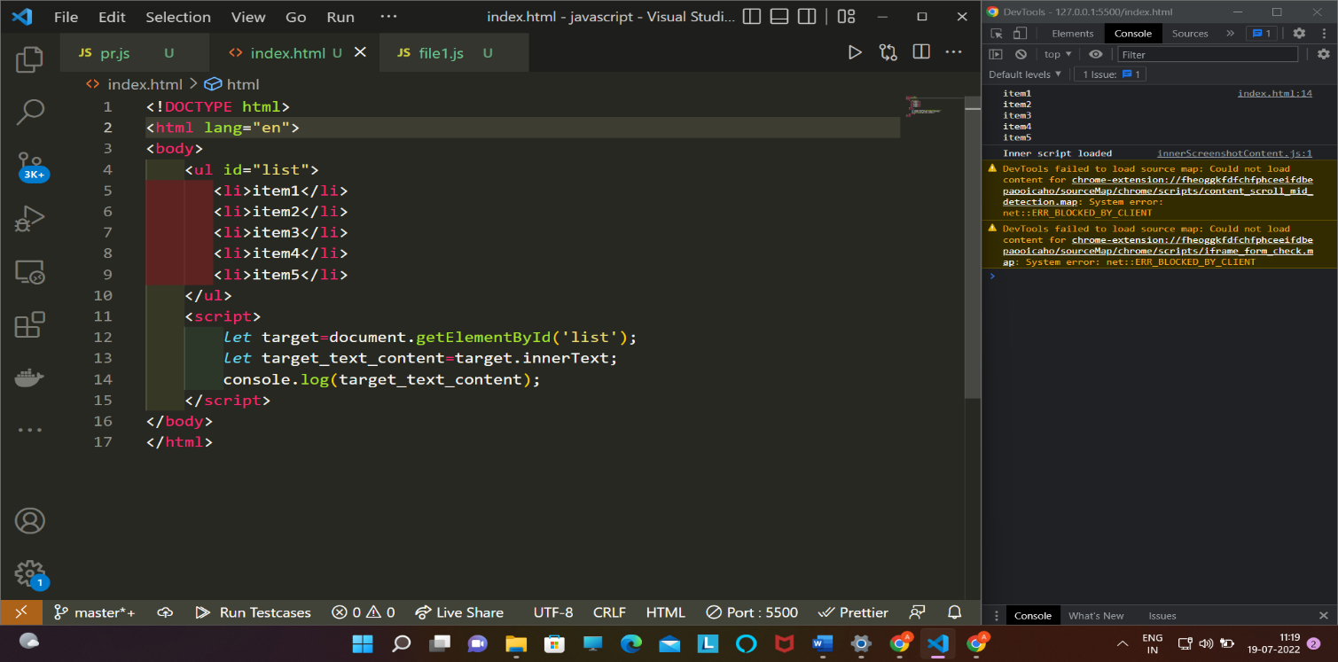

If we change the inner text it will going to create a single text node :

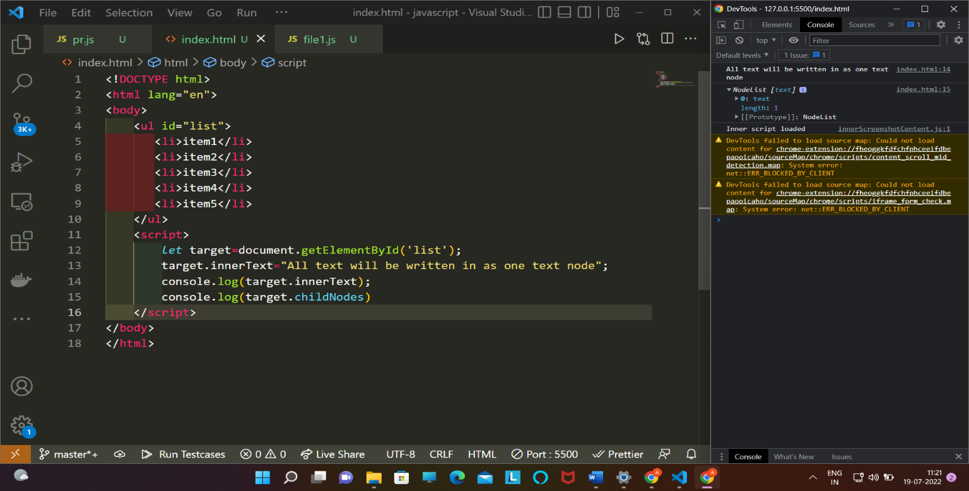

Normalize 🡺

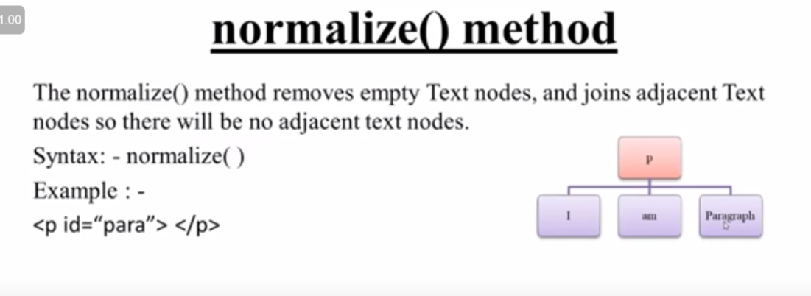

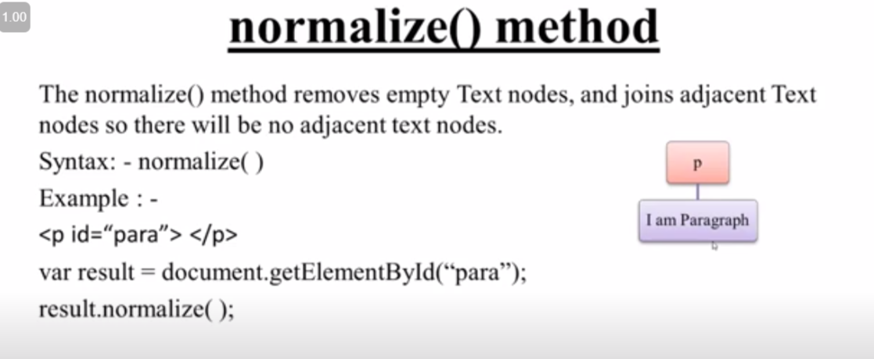

🡺.before() :

The *Element*.before() method inserts a set of *Node* or string objects in the children list of this *Element*'s parent, just before this Element. String objects are inserted as equivalent Text nodes.

before(param1)

before(param1, param2)

before(param1, param2, /* … ,*/ paramN)

[**Inserting an element**](https://developer.mozilla.org/en-US/docs/Web/API/Element/before#inserting_an_element)

*let* container = document.createElement("div");

*let* p = document.createElement("p");

container.appendChild(p);

*let* span = document.createElement("span");

p.before(span);

console.log(container.outerHTML);

// "<div><span></span><p></p></div>"

### [Inserting text](https://developer.mozilla.org/en-US/docs/Web/API/Element/before#inserting_text)

*let* container = document.createElement("div");

*let* p = document.createElement("p");

container.appendChild(p);

p.before("Text");

console.log(container.outerHTML);

### [Inserting an element and text](https://developer.mozilla.org/en-US/docs/Web/API/Element/before#inserting_an_element_and_text)

*let* container = document.createElement("div");

*let* p = document.createElement("p");

container.appendChild(p);

*let* span = document.createElement("span");

p.before(span, "Text");

console.log(container.outerHTML);

// "<div><span></span>Text<p></p></div>"

Note : before do not return any thing

🡺 InsertBefore():

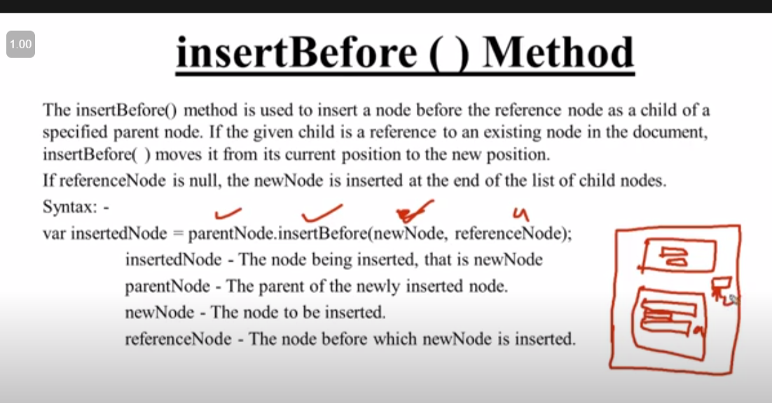

🡺insertAdjecent():

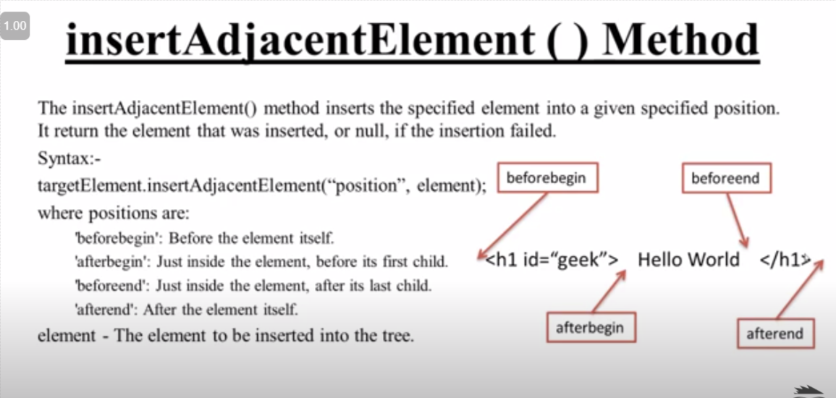

🡺insert AdjecentHtml():

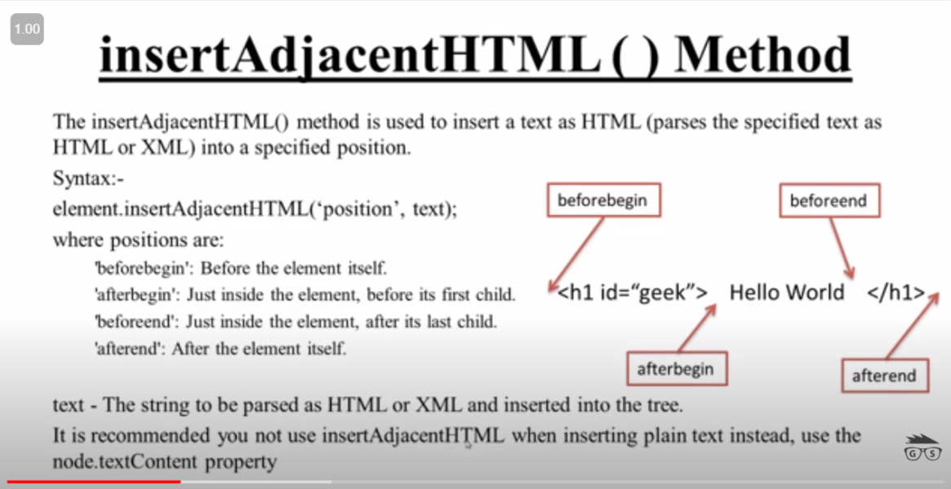

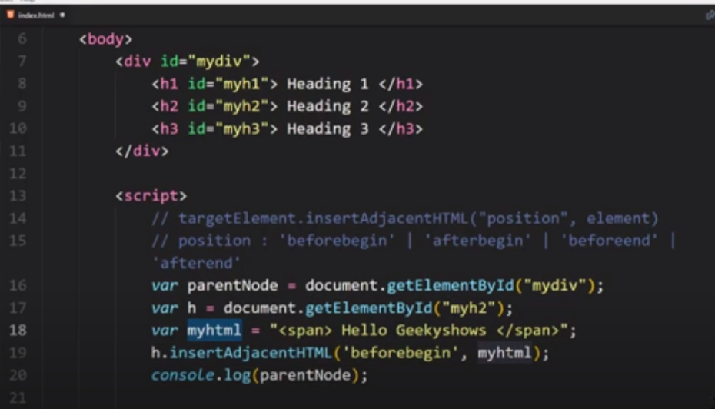

🡺insertAdjecentText():

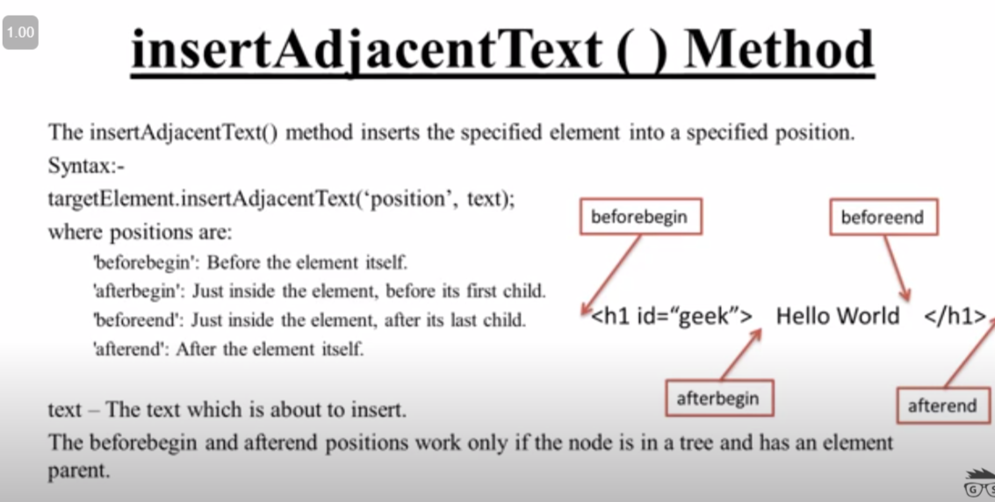

🡺outer Html :

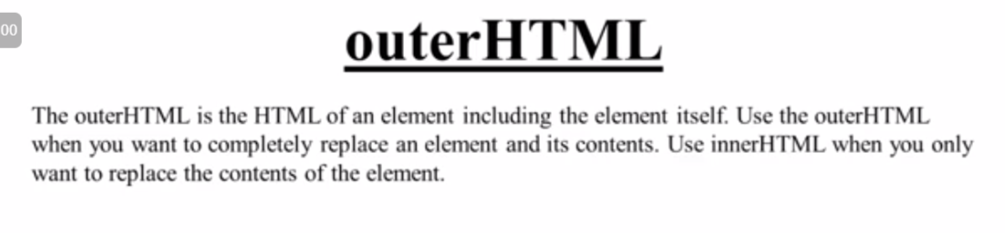

Clone node 🡺

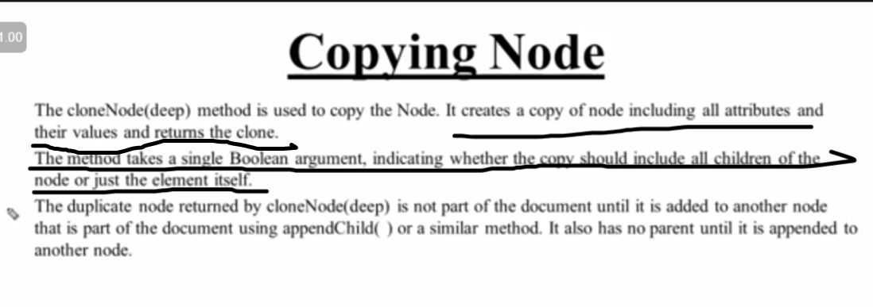



🡺 Way of delete node :

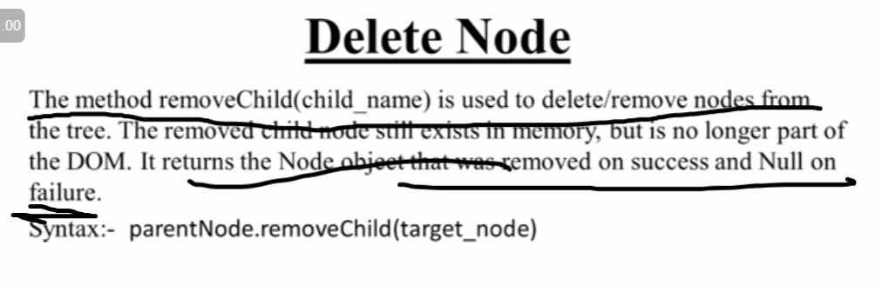

🡪Way to Replace a node :

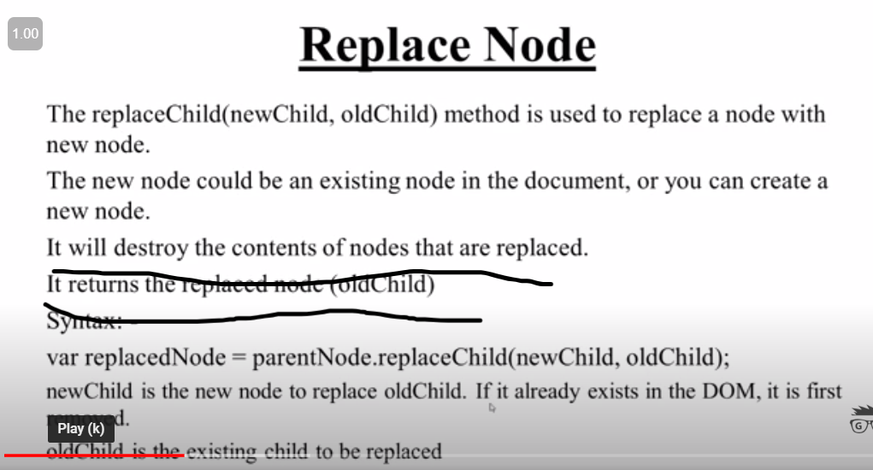

Html attributes 🡺

1.acessing attributes :we can acess attributes directly by their name and change their value as well .

2.attributes property :

a)getattributes

b)setattributes

c)removeattributes

d)has attributes

note :with the help of set attributes we can add a new attributes as well .

🡺 Dom maping :

